NAME:DENISHA SHREE R
REG NO:192524016
Task 1 – CSV File:
Student Marks Record Problem Statement Develop a Python program to collect the details of 10 students and store them in a CSV file named student_marks.csv.
The file should contain:
- Register Number •
- Student Name •
- Department •
- Python Marks
- Data Science
- Marks
CODING:
import csv
with open("student_marks.csv", "w", newline="") as file:
writer = csv.writer(file)
writer.writerow(["Register Number", "Student Name", "Department", "Python Marks", "Data Science Marks"])
for i in range(10):
reg = input("Register Number: ")
name = input("Student Name: ")
dept = input("Department: ")
python = input("Python Marks: ")
ds = input("Data Science Marks: ")
writer.writerow([reg, name, dept, python, ds])
print("Student details stored successfully.")
OUTPUT:
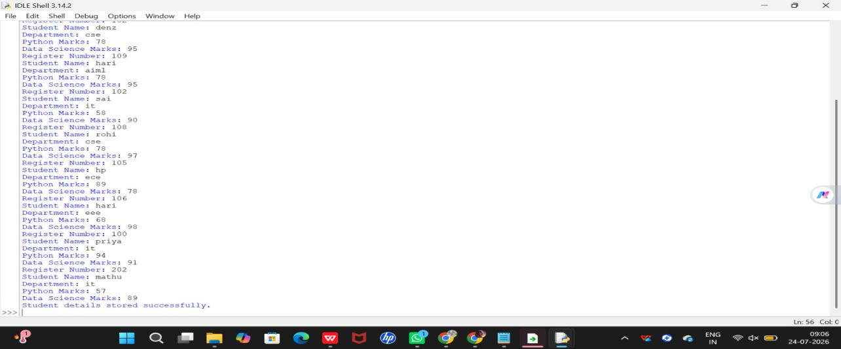
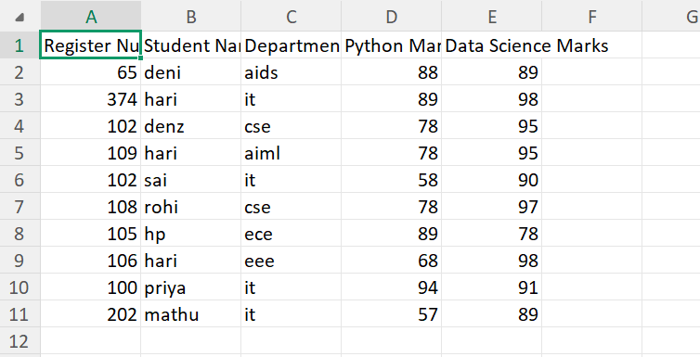
Task 2 – CSV File:
Employee Database Problem Statement Develop a Python program to collect employee information and store it in a CSV file named employees.csv.
The file should contain: •
- Employee ID •
- Employee Name •
- Department •
- Designation •
Salary Store details of at least 5 employees.
CODING:
import csv
with open("employees.csv", "w", newline="") as file:
writer = csv.writer(file)
writer.writerow(["Employee ID", "Employee Name", "Department", "Designation", "Salary"])
for i in range(5):
empid = input("Employee ID: ")
name = input("Employee Name: ")
dept = input("Department: ")
desig = input("Designation: ")
salary = input("Salary: ")
writer.writerow([empid, name, dept, desig, salary])
print("Employee details stored successfully.")

OUTPUT:
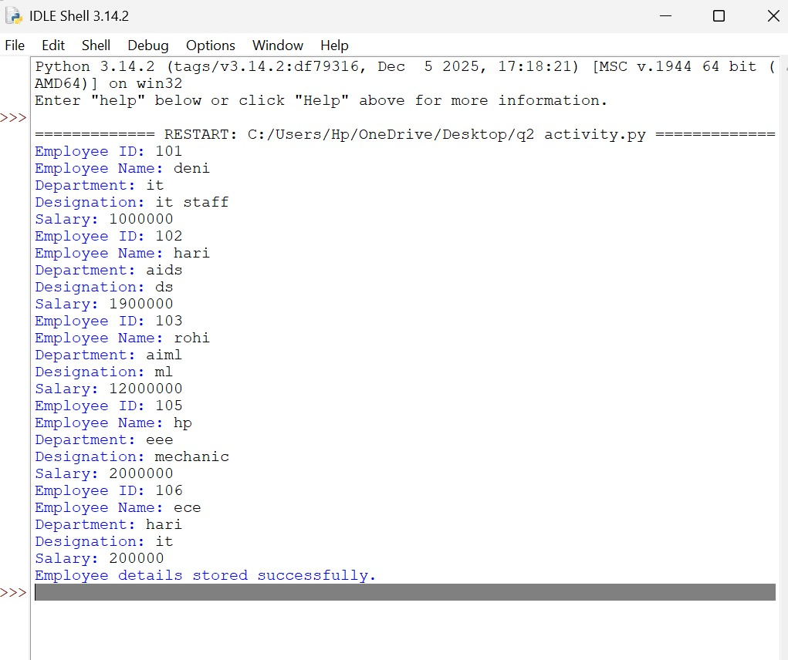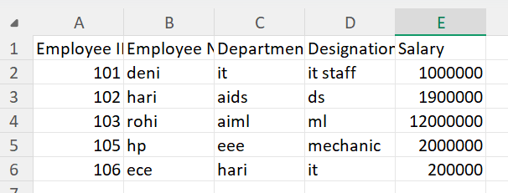
Task 3 – JSON File:
Faculty Information System Problem Statement Create a Python program to collect faculty details and store them in a JSON file named faculty.json.
Each faculty record should contain:
- Faculty ID
- Faculty Name
- Department
- Designation
Experience (Years) Store details of at least 5 faculty members.
CODING:
import json
faculty = []
for i in range(5):
data = {
"Faculty ID": input("Faculty ID: "),
"Faculty Name": input("Faculty Name: "),
"Department": input("Department: "),
"Designation": input("Designation: "),
"Experience": input("Experience (Years): ")
}
faculty.append(data)
with open("faculty.json", "w") as file:
json.dump(faculty, file, indent=4)
print("Faculty details stored successfully.")
OUTPUT:
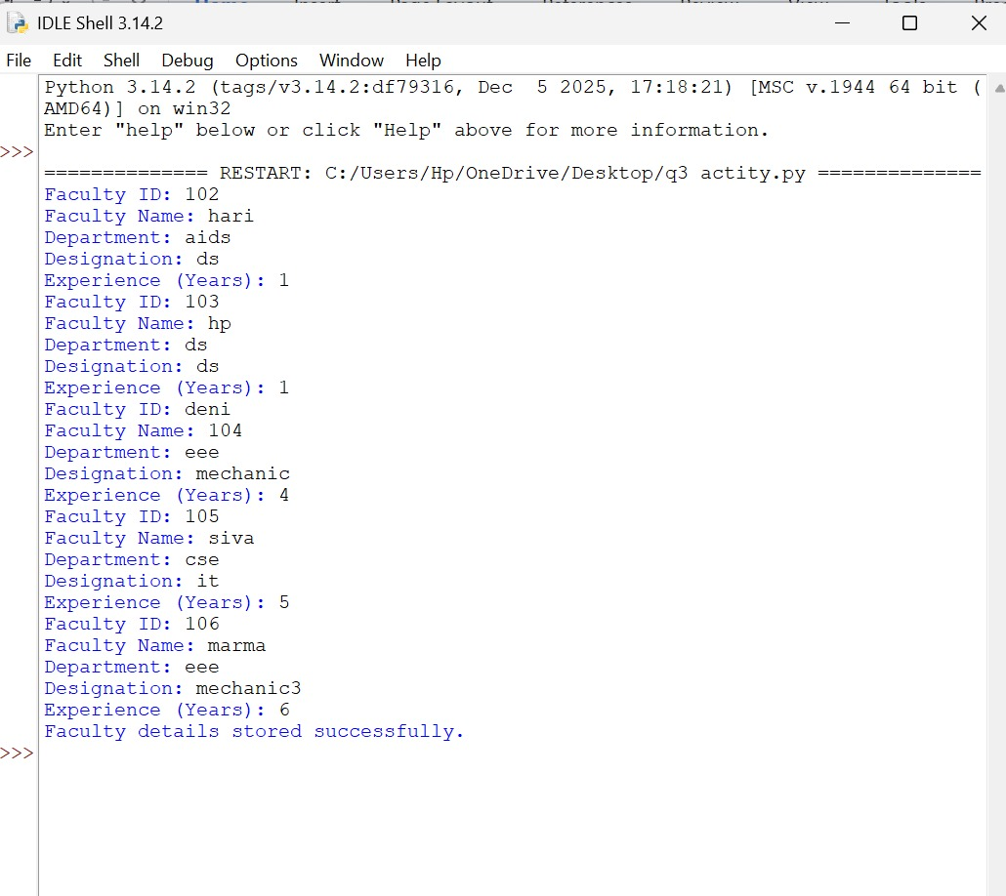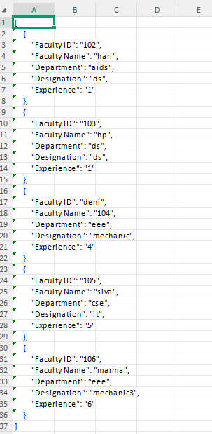
Task 4 – JSON File:
Product Inventory Management Problem Statement Develop a Python program to collect product information and store it in a JSON file named products.json. Each product should contain: •
- Product ID
- Product Name
- Category •
- Price •
Quantity Available Store details of at least 10 products.
CODING:
import json
products = []
for i in range(10):
product = {
"Product ID": input("Product ID: "),
"Product Name": input("Product Name: "),
"Category": input("Category: "),
"Price": input("Price: "),
"Quantity": input("Quantity Available: ")
}
products.append(product)
with open("products.json", "w") as file:
json.dump(products, file, indent=4)
print("Product details stored successfully.")
OUTPUT:
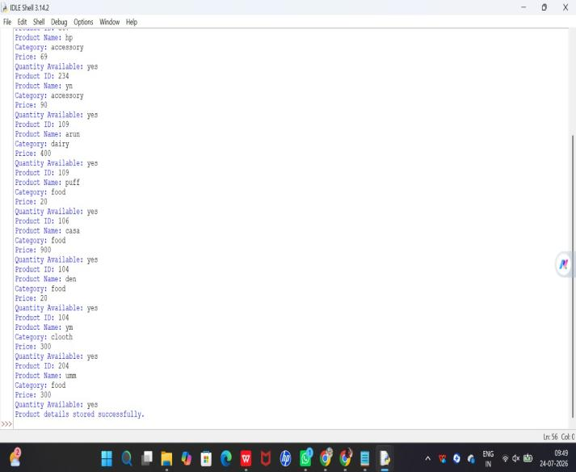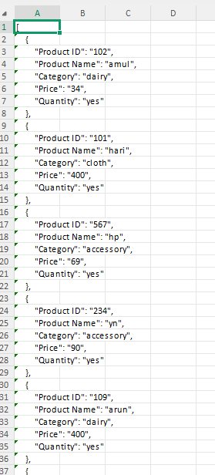
Task 5 – XML File:
Course Information Database Problem Statement Create a Python program to collect course details and store them in an XML file named courses.xml.
Each course should contain:
- Course Code •
- Course Name
- Credits •
- Department
Faculty Name Store details of at least 5 courses.
CODING:
import xml.etree.ElementTree as ET
root = ET.Element("Courses")
for i in range(5):
course = ET.SubElement(root, "Course")
ET.SubElement(course, "CourseCode").text = input("Course Code: ")
ET.SubElement(course, "CourseName").text = input("Course Name: ")
ET.SubElement(course, "Credits").text = input("Credits: ")
ET.SubElement(course, "Department").text = input("Department: ")
ET.SubElement(course, "FacultyName").text = input("Faculty Name: ")
tree = ET.ElementTree(root)
tree.write("courses.xml")
print("Course details stored successfully.")
OUTPUT:
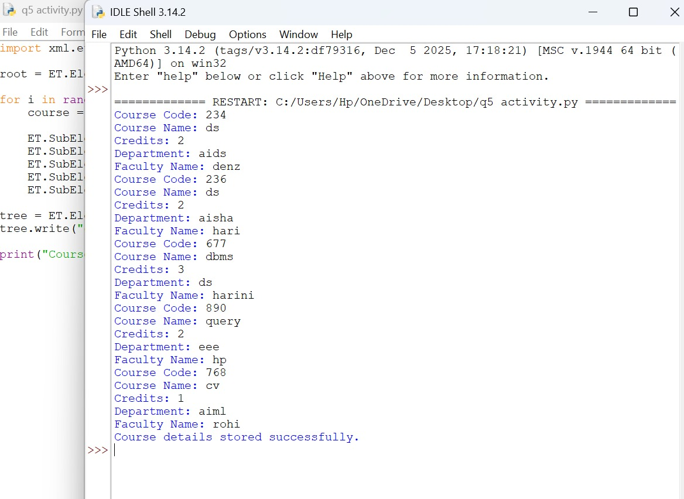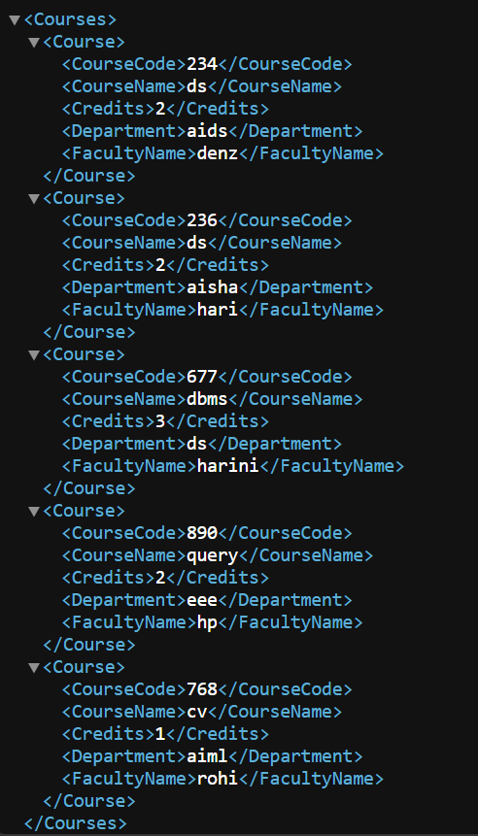
Task 6 – XML File:
Hospital Patient Management System Problem StatementDevelop a Python program to collect patient information and store it in an XML file named patients.xml.
Each patient record should contain:
- Patient ID •
- Patient Name •
- Age •
- Disease •
Doctor Assigned Store details of at least 10 patients.
CODING:
